Nexora public website
Document 28 of the Nexora learning guides
Source snapshot 14 October 2026 at 06:41 UTC
Understand visitor routes, published content rendering, navigation, media and sitemap.

Recognise the screen and its scope
Open /site/[siteId], /site/[siteId]/[slug], /site/[siteId]/media/[id], /site/[siteId]/sitemap.xml. CRM routes use port 3017; member routes use 3018; public website routes can use 3019. Brackets name a route parameter, not text to paste into a browser. Choose a real record or site id from the application.
This guide covers Published home and pages; Site navigation and portal link; SEO metadata canonical links and sitemap; Redirects; Public clean media; Block rendering theme and motion.
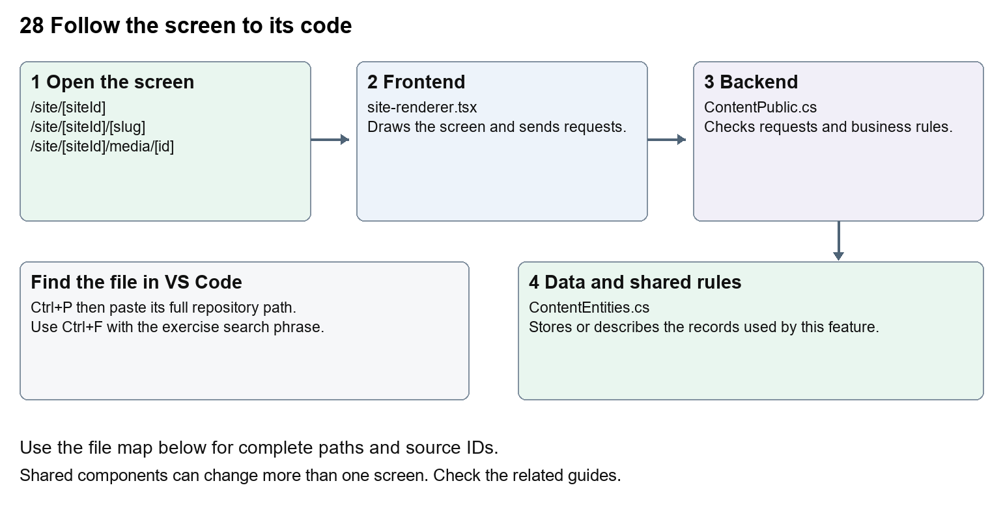
The diagram shows the file roles. The full paths below are what you paste into Ctrl+P.

Find the files in VS Code
Role | File and source ID | What it does
Screen | S0068 site-renderer.tsx | Main UI or route for this topic
Server | S0220 ContentPublic.cs | Endpoints or server rules
Data | S0217 ContentEntities.cs | Data shape or persistence structure

Screen S0068
apps/web/src/features/content/site-renderer.tsx
Server S0220
backend/src/Modules/Nexora.Modules.Content/ContentPublic.cs
Data S0217
backend/src/Modules/Nexora.Modules.Content/ContentEntities.cs
The complete HTML manual opens these source IDs inside its Source library. The Word manual shows short labelled extracts so you can learn the flow before reading large files. Each individual Markdown guide includes its complete primary files after the walkthrough.

Follow the request and the records
1. A public route receives siteId and optional slug.
2. The route requests published page data from the API.
3. ContentPublic checks the site, publication and media availability.
4. SiteRenderer draws blocks with published layout and design.
5. Navigation, portal links and sitemap use published page addresses.

Read the code with an explanation
The route is the entry point, but the page text lives in saved revisions. SiteRenderer switches on each block type, so a new block type needs matching types, editor controls, validation and rendering. Motion fields affect how content enters and responds to hover. Respect reduced-motion settings. A media URL is checked by the backend before data is returned.
Source reference S0068 apps/web/src/features/content/site-renderer.tsx
Selected opening lines with their original numbers. The complete file is in the HTML source library.
0001 "use client";
0002 /* eslint-disable @next/next/no-img-element -- Media URLs enforce tenant, scan and public-grant checks. */
0003 import { useEffect, useId, useRef, useState, type CSSProperties, type ReactNode } from "react";
0004 import type { BlockItem, PublicPage, WebsiteMotion } from "./types";
0005 import { defaultDesign, defaultLayout } from "./website-design";
0006 import "./site.css";

The import lines lead to shared components and helpers. Start at the exported component or route function; follow the request helper to the server rather than assuming the whole feature lives in this file.
Source reference S0220 backend/src/Modules/Nexora.Modules.Content/ContentPublic.cs
Extract from source line 40. A fragment from a long line is shown without the rest of that line.
0040 endpoints.MapGet("/api/v1/public/portal-appearance", async (C

On the server, look for MapGet to load records, MapPost to create or perform an action, MapPut or MapPatch to change data, and RequireAuthorization for permissions. Some shared methods register endpoints indirectly. Find SaveChangesAsync to see the database write. A request method alone does not tell you every side effect.
Source reference S0217 backend/src/Modules/Nexora.Modules.Content/ContentEntities.cs
Selected opening lines with their original numbers. The complete file is in the HTML source library.
0001 using Nexora.BuildingBlocks.Domain;
0003 namespace Nexora.Modules.Content;
0005 public sealed class Site : TenantEntity
0006 {
0007 public string Name { get; set; } = "";
0008 public string Tagline { get; set; } = "";

Follow model fields to their request names and database mapping. An id points to a particular record. A tenant id limits the organisation. A version or concurrency stamp protects newer edits. Some model files describe contracts rather than tables; check the owning DbContext before assuming storage.

Make or trace your first change
1. Press Ctrl+P and open apps/web/src/features/content/site-renderer.tsx.
2. Press Ctrl+F and search for export function. In this snapshot it appears at line 57.
3. Read-only exercise: locate SiteRenderer, find how it chooses block types, then follow a hero block back to the editor types. Use CRM to preview changed text; do not replace a saved page with a hardcoded route.
4. Record the file, request path and server handler you found. This exercise is read-only; no stored records need to change.
Extract from source line 57. A fragment from a long line is shown without the rest of that line.
0057 export function SiteRenderer({ content, preview = false }: { content: PublicPage; preview?: boolean }) {

These exercises have not been applied to the application. Their search phrases are verified against the captured source. Line numbers can move; the phrase and file path are your main navigation aids.

Check a change and diagnose problems
Confirm the original screen still loads, the changed words appear in the intended place, and another screen using the same component still behaves correctly. If an action fails, inspect the browser Network response, the relevant helper and server validation message. Use the common error table at the beginning of the manual. Reload on a version conflict instead of removing the version check.
A syntax error after a text edit usually means a quote, brace or closing tag changed. Compare your diff with the original. An unchanged browser result can mean the wrong port, a saved published configuration overriding a default, or a running API that has not reloaded.

Understand the current limits
The public demo is not evidence of live event booking, payments or enquiry delivery. Only published content is visible to anonymous visitors. Registration and member actions belong to the portal access boundary.

Continue learning
Related guides 24 Nexora member portal login and onboarding, 27 Nexora website editor and publishing, 29 Nexora documents evidence and file safety.

